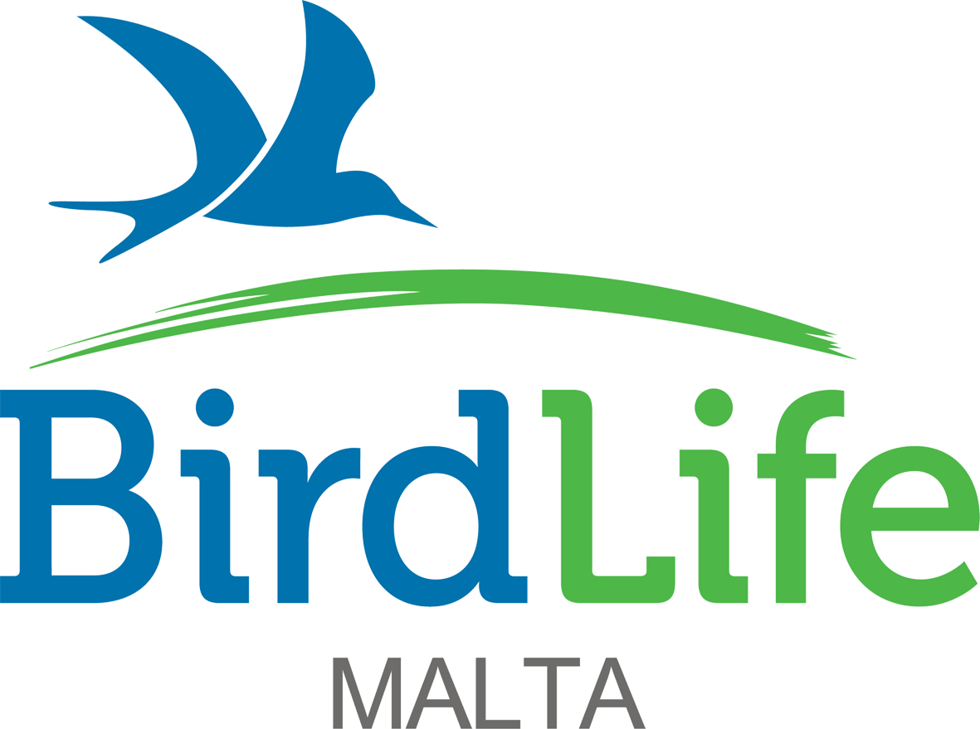
FOR BIRDLIFE MALTA
USE ONLY
ACKNOWLEDGE

57/28, Abate Rigord Street, Ta’ Xbiex XBX1120, Malta

APPLICATION FOR

EUROPEAN SOLIDARITY CORPS

VACANCIES
(OPEN ONLY FOR APPLICANTS FROM PROGRAMME
AND PARTNER COUNTRIES LISTED BELOW)

Closing date Wednesday 20th January 2021 at noon

STRICTLY CONFIDENTIAL
THE INFORMATION CONTAINED IN THIS APPLICATION FORM WILL BE USED SOLELY FOR THE PURPOSE OF THE EMPLOYMENT OF THE ABOVE MENTIONED POST AND UNLESS OTHERWISE REQUESTED BY THE APPLICANT, WILL BE RETAINED BY BIRDLIFE MALTA FOR STAFF RECRUITMENT PURPOSES IN THE EVENT OF ANY ADDITIONAL FUTURE VACANCIES.

How did you learn of this vacancy?

Personal details
(Boxes expand automatically as you type.)
Surname |  | Dr/Mr/Mrs/Miss/Ms/Other

Name(s)

Address

Postcode

Home Tel no |  | Business Tel no

Mobile Tel no |  | Other Tel no

European Solidarity Corps Participant Reference Number (PASS)

May we, with discretion, phone you at work? Yes No
Do you hold a full driving licence? Yes No

Meeting European Solidarity Corps criteria
Erasmus+ volunteers must be aged between 18-30 and be citizens of one of the following partner and programme countries: Italy, Spain, France, UK, Poland, Portugal, Ukraine and Belarus. Please confirm the following details about yourself below.

I confirm that I will be aged between 18-30 on the date of the application deadline Yes
I confirm that I am a citizen of one of the programme or partner countries Yes

Which role are you applying for and why are you interested in this role?

(Please tick ONLY one of the volunteering positions and briefly explain why you are applying for this role in the box. If applying for more than one volunteering position, please fill in a separate application form).

Nature Reserves: Nature Reserves Visitor Assistant
Communications: Communications Assistant
Communications: Design & Digital Media Assistant
Admin: Administration & Finance Assistant

Qualifications
List the qualifications you have taken or are about to take.

Type of qualification | Subject | Result/date | Type of qualification | Subject | Result/date

Language skills

Language:

Mother tongue | Fluent | Intermediate | Basic

Language:

Mother tongue | Fluent | Intermediate | Basic

Language:

Mother tongue | Fluent | Intermediate | Basic

Language:

Mother tongue | Fluent | Intermediate | Basic

Past employment details (Excluding your present or last employment)

Employer’s name & address | Job title | Date |  | Salary | Reasons for leaving
 |  | From | To

Present or last employer/volunteer role details
Company name and address

Postcode

Position held

Dates from |  | To

Final or most recent salary and benefits

Outline present duties

Reasons for wishing to leave your present role

Relevant experience
Please use the short role descriptions to indicate where you have relevant skills and experience to the internships you are especially interested in. (Please draw from past employment and/or voluntary activities. Please give details of any scientific papers you have had published.) Indicate the number of years you have been involved in the duties mentioned and relevant job or volunteer role titles.

Training courses
Detail below any specialised training you have received or any relevant short courses attended.

Spare time interests and vocational activities

Criminal record
Have you ever been prosecuted or convicted in connection with any offence and is there any pending prosecution? Please give details.

Length of notice

Declaration
I confirm that the information contained in this application form is correct.

Signature

Date

